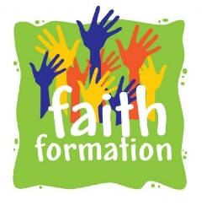
Catholic Community of Holy Family, Sacred Heart, St. Alphonsus and St. Ann
Faith Formation Office, 90 Melrose Rd. Auburn, NY13021
Barbara Quinn, Coordinator of Faith Formation
Email: Barbara.Quinn@dor.org Telephone: 315. 252.7271 ex. 204

2024-2025 Sunday Program Schedule 10am-11:15am Sacred Heart
9/15/24 Catechist Sunday
9/22/24
9/29/24
10/6/24
10/13/24 No Class Columbus Day Weekend
10/20/24
10/27/24
11/3/24
11/10/24 No Class Veteran’s Day Weekend
11/17/24
11/24/24
12/1/24
12/8/24
12/15/24 Advent Activities and Mass
12/22/24-1/19/25 No Classes Christmas Break
1/26/25 2nd Semester Begins
2/2/25
2/9/25
2/16/25 No Class Midwinter Break
2/23/25
3/2/25
3/9/25
3/16/25
3/23/25
3/30/25
4/6/25 Last Class, All Classes Celebration Mass

